|  |  |
| --- | --- |
| PlotEmpiricalCurve {RJafroc} | R Documentation |

Plot empirical curve

**Description**

Plot empirical (trapezoidal) curves of specified operating characteristic for specified modalities and readers.

**Usage**

PlotEmpiricalCurve(data, modalities, readers, legendPosition = "right",

curve = "ROC")

**Arguments**

|  |  |
| --- | --- |
| data | Dataset to be used for plotting. |
| modalities | List or vector: indices of modalities to be plotted. See "Details". |
| readers | List or vector: indices of readers to be plotted. See "Details". |
| legendPosition | The positioning of the legend: "right"(the default), "left", "top" or "bottom". |
| OpChType | Type of operating characteristic to be plotted. Available choices are "ROC"(the default), "AFROC" and "FROC". |

**Details**

**Note** that modalities and readers are the vectors or list of **indices** not **IDs**. For example, if the ID of the first reader is "0". The corresponding value in modalities should be **1** but not 0.

If both of modalities and readers are vectors, all possible combinations will be plotted.

If both of modalities and readers are lists, they must have same length. Only the combination of modality and reader at same position will be plotted. If some elements of the lists are vectors, the averaged curve over them will be plotted. See "Examples".

**Value**

A **ggplot2** object of the plotted curves and a data frame containing the points of the curves are returned. Following are the returned objects of ROC curves.

|  |  |
| --- | --- |
| ROCPlot | **A ggplot2** object: use **print** function to display the saved object. |
| ROCPoints | A list of 10, the first member $data is a data frame with four columns: abscissa, ordinate, class (coding modality and reader) and type, which can be "individual" or "averaged" |

**I am not sure I understand this table; talk Friday;**

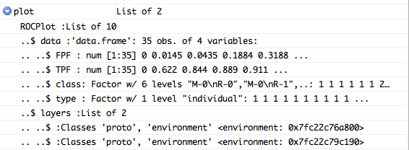

**DPC comment: FPF and TPF apply only to ROC data; axes change depending on type of plot; to be consistent replace FPF with xCoord and TPF wlth yCoord; as you know, the field is confused enough already; let us not add to it;**

**Examples**

plotM <- c(1:2)

plotR <- c(1:3)

PlotEmpiricalCurve(data = vanDykeData, modalities = plotM, readers = plotR,

legendPosition = "bottom", curve = "ROC")

## Above is the example of plotting individual ROC curves of modalities 1 and 2 and readers 1 to 3.

## Six curves will be plotted, which are curves of reader 1 modality 1, reader 1 modality 2, reader 2 modality 1,

## reader 2 modality 2, reader 3 modality 1 and reader 3 modality 2.

plotM <- list(1, 2, c(1:2))

plotR <- list(2, c(2:3), c(1:3))

PlotEmpiricalCurve(data = vanDykeData, modalities = plotM, readers = plotR,

legendPosition = "bottom", curve = "ROC")

PlotEmpiricalCurve(data = frocData, modalities = plotM, readers = plotR,

legendPosition = "bottom", curve = "AFROC")

PlotEmpiricalCurve(data = frocData, modalities = plotM, readers = plotR,

legendPosition = "bottom", curve = "FROC")

## Above is the example of plotting three ROC, AFROC and FROC curves. They are the individual curve of modality 1 reader 1,

## the averaged curve of modality 2 and reader 2 and 3 and the averaged curve of modality 1 and 2 and reader 1 to 3.

Your frocData object does not appear to be a genuine FROC dataset: the curves don't level off: see below;

Also please use proper grammar in documentation: use complete sentences and run spell check before giving me the next version.

**In AFROC plot (see below) the last segment, going to (1,1) must be dotted; it is not physically accessible to reader;**

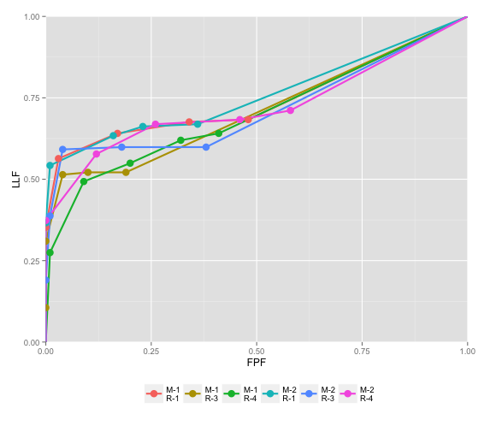

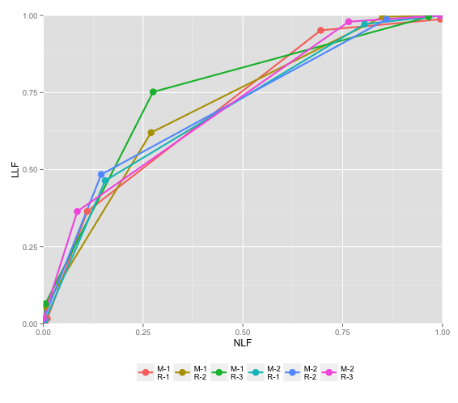

Use FedericaAll.xlsx (in your folder) instead; just don't name the embedded dataset using her name;

